Abdulla Aigerim Arystankyzy

Task:1

<https://www.w3schools.com/GIT/exercise.asp>

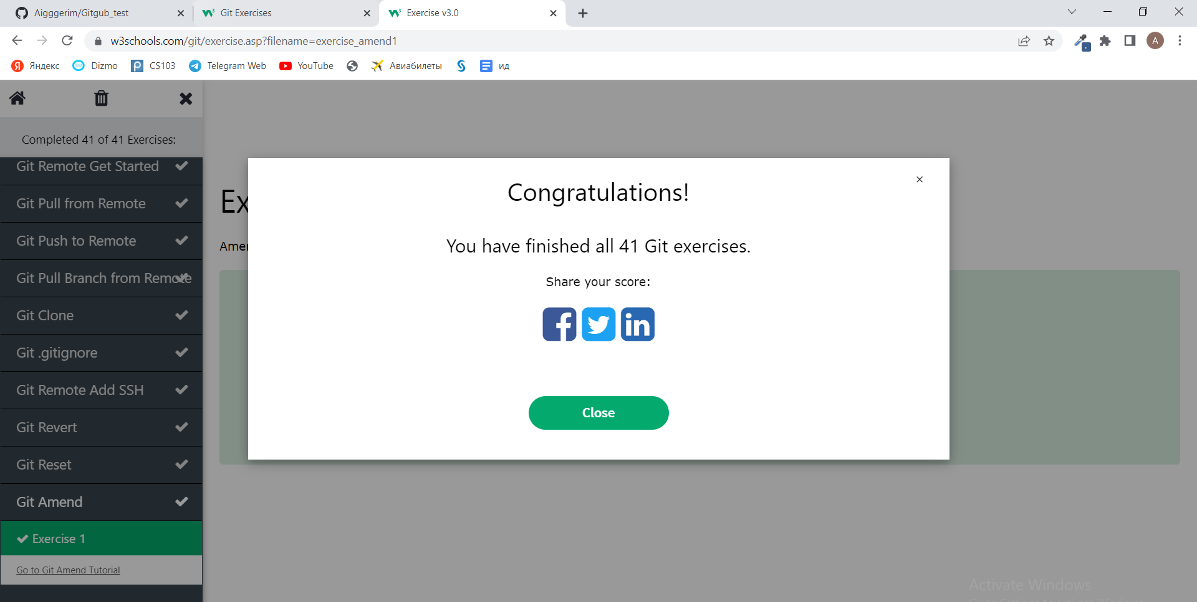

Task 2:

Firstly, I fork repository on github.

1) сделайте какое то изменение и сделайте PR (pull request).

Cloning repository:

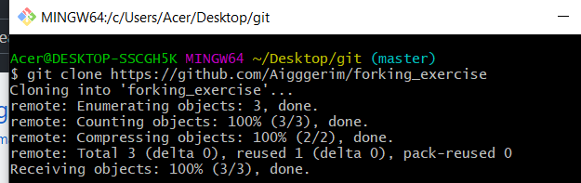

Checking branches and creating new branch:

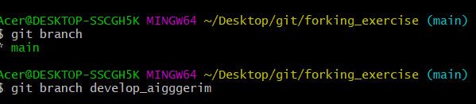

Switching to the new branch that we have already created:

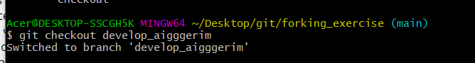

Changed file 1.txt

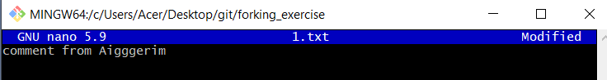

After that I checked my commit with cat command then pushed it:

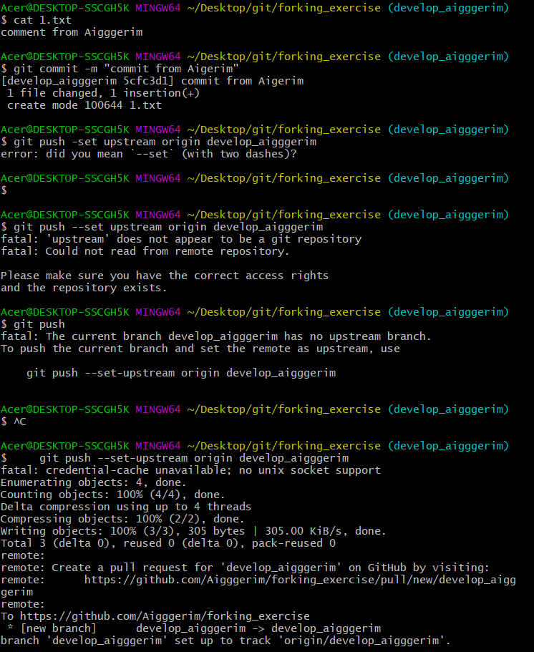

Then I switched to main branch and merge it with the branch that I created

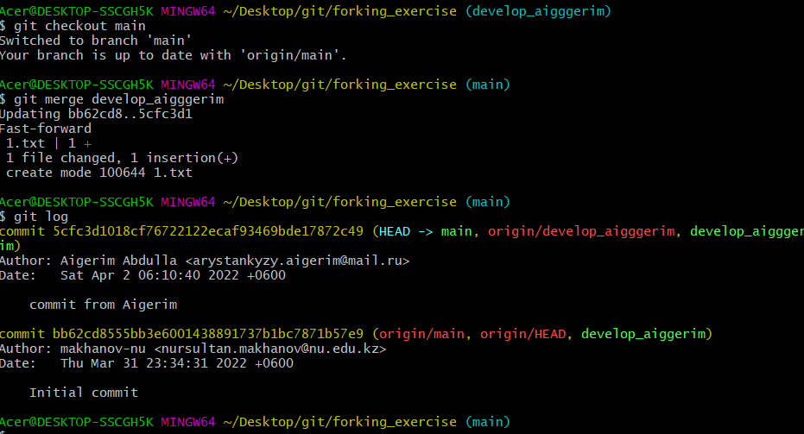

2) Change to a different branch and add some files and merge into main when you are done

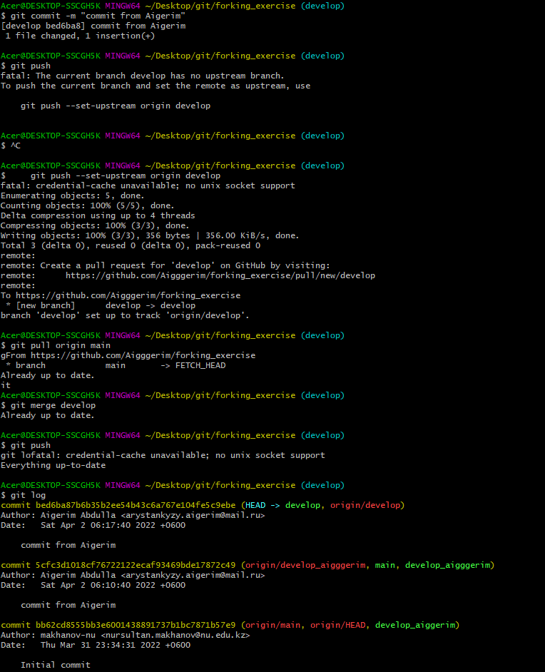

3)

Practice using revert to undo commits and rebase with interactive mode for a better commit history

Changing something in a file 1.txt then reverting it:

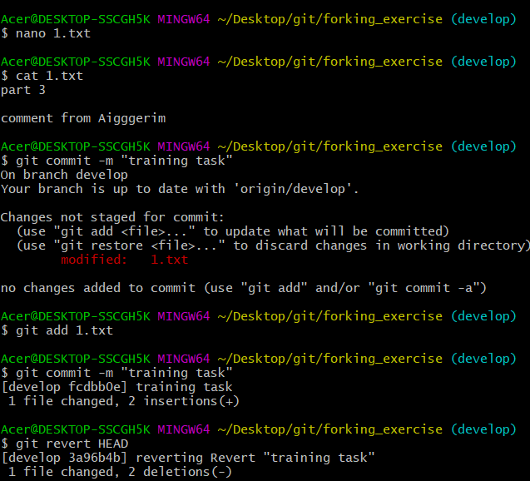

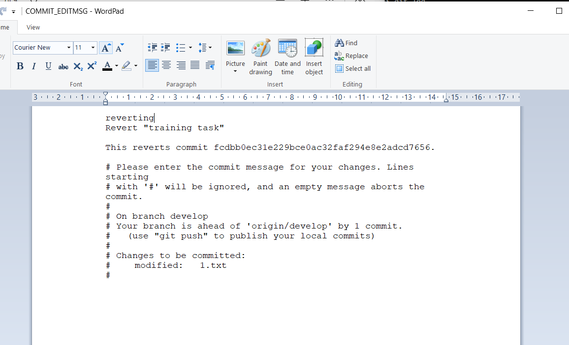

4) • Submit another pull request, with squashed commits.

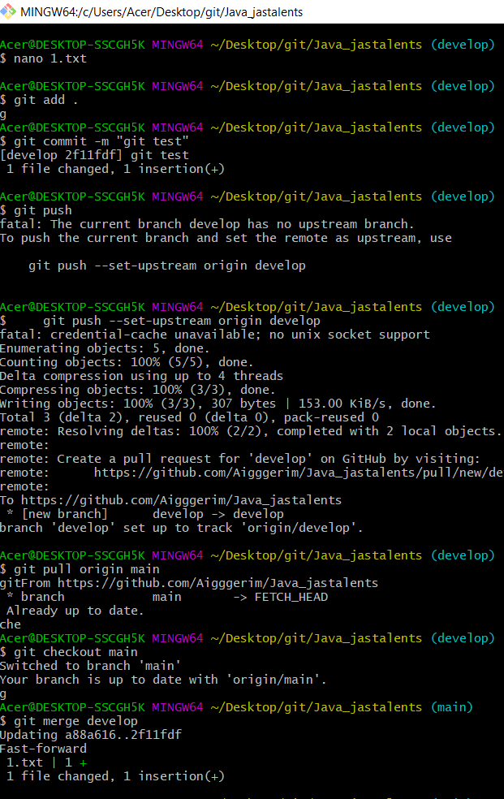

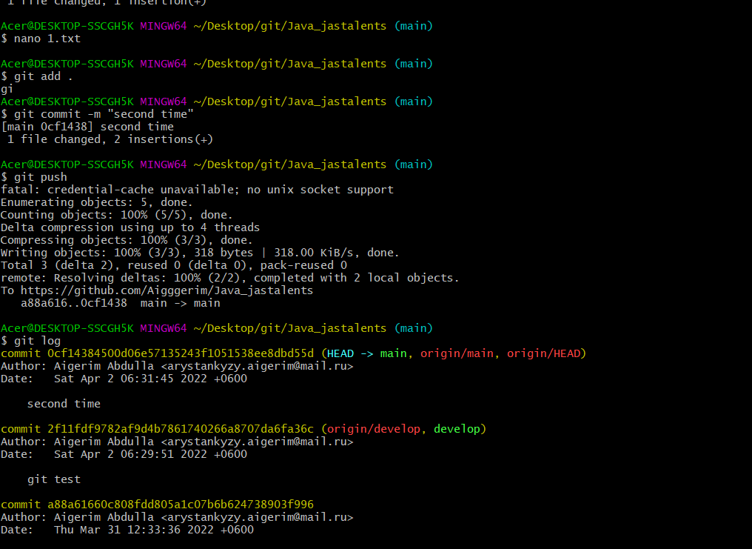

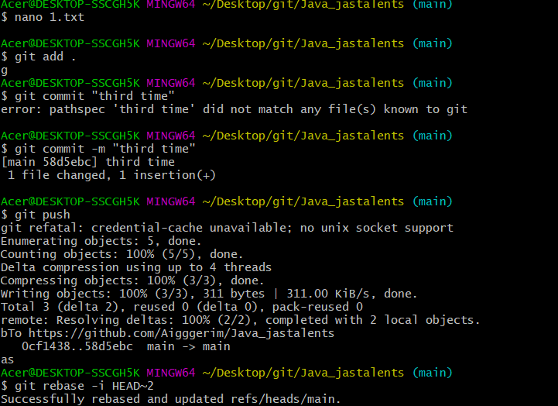

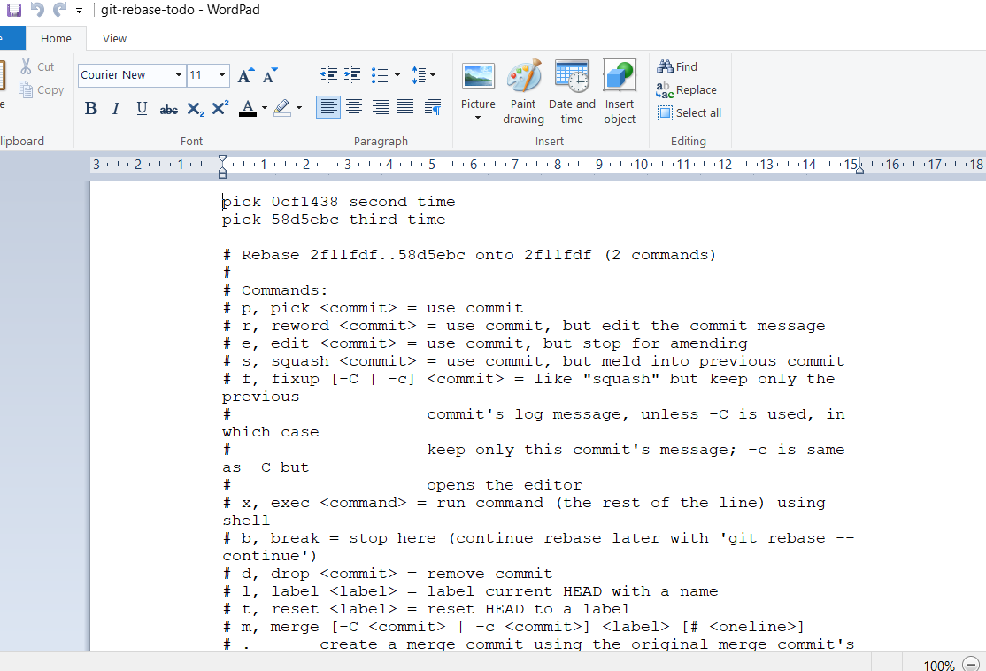

Task 3:

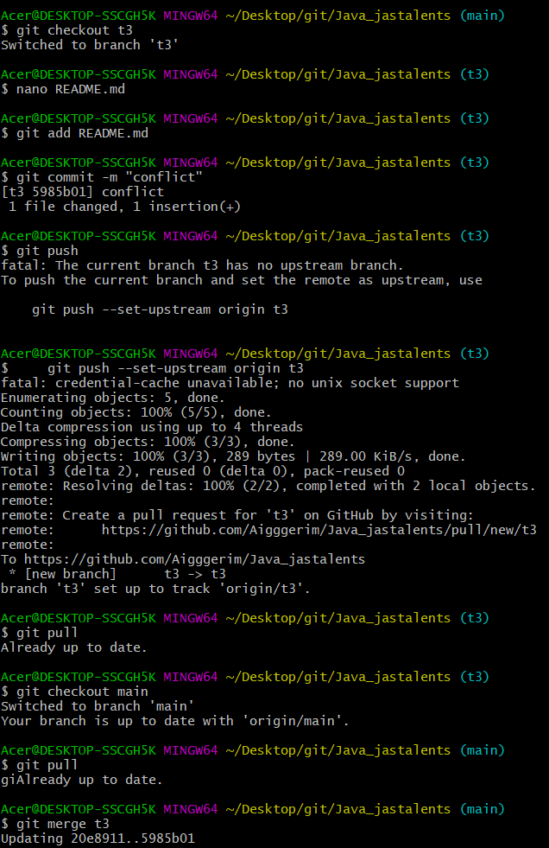

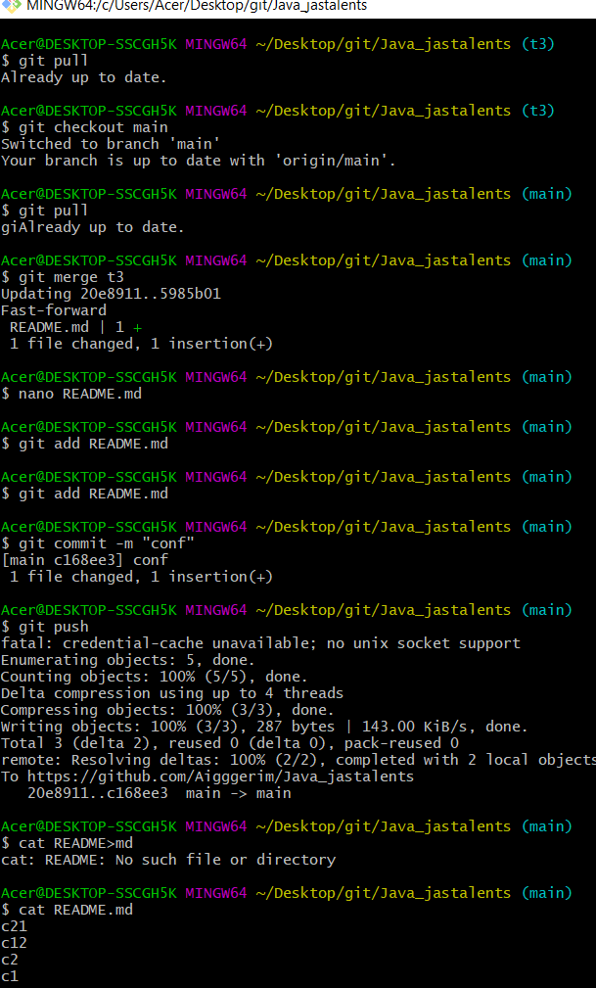

• Потом сгенерируйте конфликт в бранче. Тоже напишите решение.

Nano 1.txt

Git add 1.txt

Git commit –m “conf”

Git push

Git pull

Git checkput develop

Git merge main

Nano 1.txt

Git add .

Git commit –m “conf”

Git push

TASK 4: --

TASK 5:

